Create user on windows server

We create windows vm and in order to give access either we can create a IAM user by selecting existing users on SNP tenant or we can add the server to a domain and create user.

Can we create login user as we create on linux.

Login to the server.

Search for users

Go for add edit or remove users

Then add user

It will navigate to local users and groups management console.

We can see build in user Partha. Let’s add another user.

Right click and choose add new user.

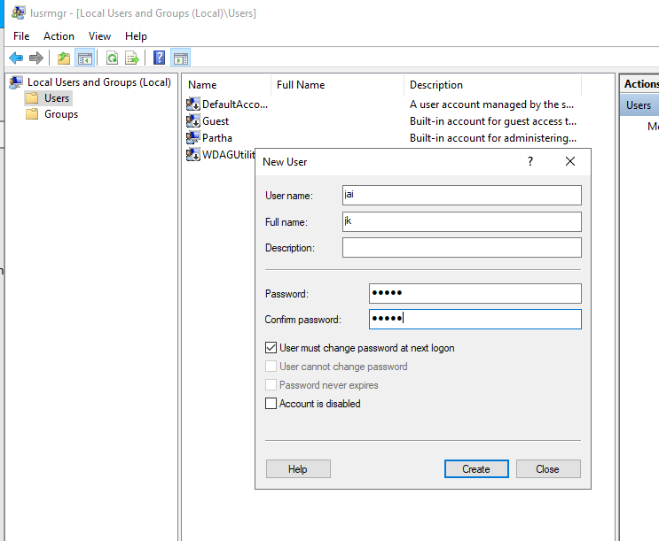

The account is created.

Here also it applicable that the user is part of which group

Try to login by that user

Login failed, let’s add the user to admin group.

By default it’s taking that user must reset password on next login which is not working. Eve I did change for the admin user that admin user need to reset password on next login that to did not worked.

Now I am also not able to login.

Hmmmm….! Yes I can give access to another iam user and try to login by that user and fix it.

But the user I was previously using “Partha” is also not a IAM user it was a local user. So I can enable IAM for myself.

Enable identity.

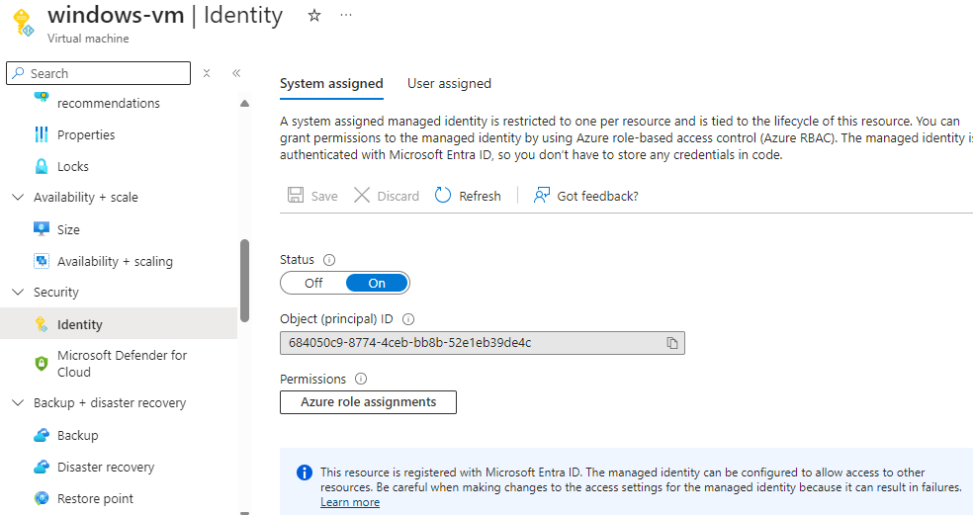

Try to login by [Parthasarathi.p@snp.com](mailto:Parthasarathi.p@snp.com) account.

We need to assign login role for the user.

Assigned contributor role as well but it did not work failed to login.

Reset password from azure portal and that worked to login admin user by using new password.

And also it disabled that password reset operation.

Note- we can’t perform reset password operation for cloud servers.

Now assign admin permission to new created user so the user must be able to login.

Let’s try to login by using iam user.

Getting error-

Available user role-

Here the issue was we need to enable entra id authentication.

After assigning the role still we see same error. So I had created a new vm, I enabled entra id login during creation and tried to login by snp account it worked.

So I just verified on vm AD connection extension should be installed.

But in my vm it was not installed.

I searched for related extension and installed.

Then it worked.

Still not able to login because I had removed roles on vm. Add vm admin login role for the user.

Now retry login.

Now configure local user to login to the vm.

Change local created user to admin.

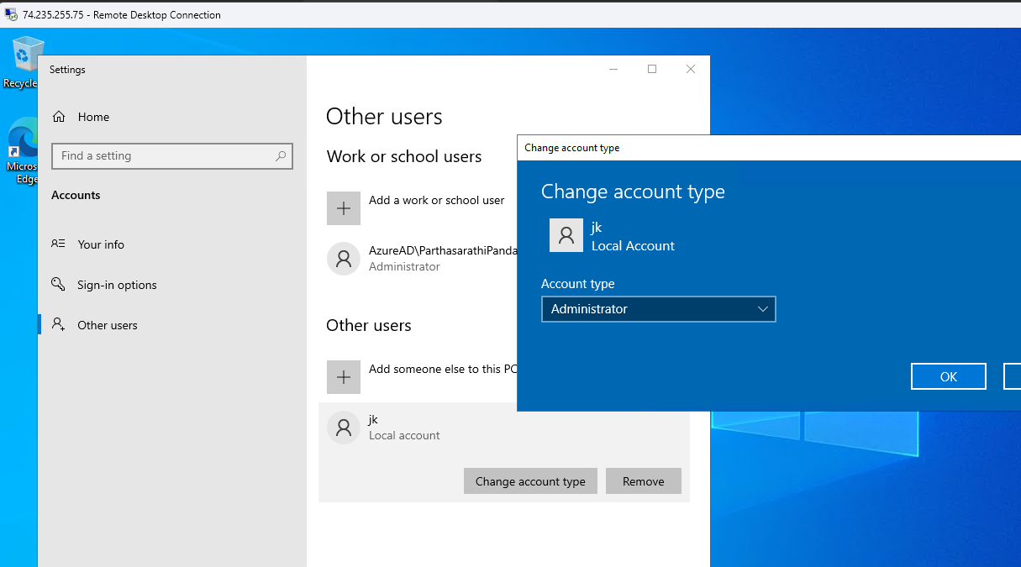

Now I am able to login by that user but I forgot the password.

Reset the password for the user from azure portal.

Try login. Login successful.

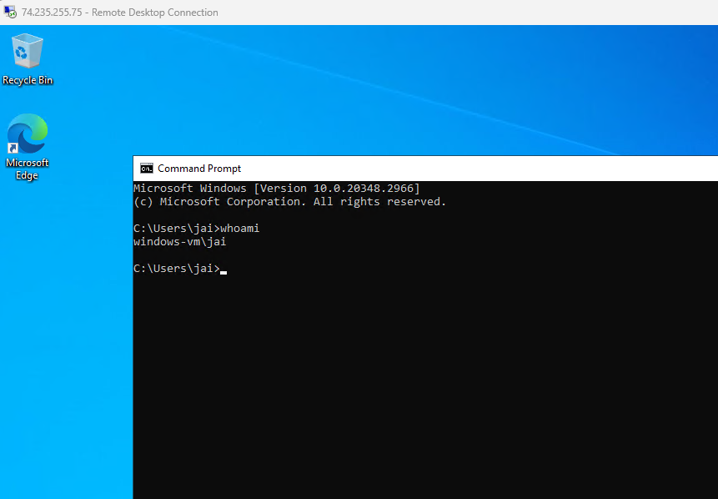

Created a folder by using account jai

Let’s login by other user and check is the file available for them.

No the file and solders are not available for other users.



Let’s try to do all add new user assign admin permissions by PowerShell cmd.

Step 1-

**Add a New User**:

* Login to the server and run PowerShell as administrator.
* Use the net user command to create a new user. Replace username and password with your desired values.

>> net user username password /add

Step 2-

**Grant the User Administrative Privileges (Optional)**:

* If the user needs admin rights, add them to the Administrators group:

>> net localgroup Administrators username /add

Try login.

Password did not worked so I reset password from azure.

